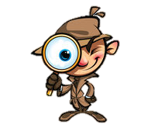


THIEVES
Title What do I think the text will be about?
What do I think the author’s message will be?
What is my background knowledge?

Headings How has the information been divided into smaller topics?
What are the smaller topics?
What do I think I will read in each section?
How will the topics relate to the big picture?

Introduction How does the introduction try to make me curious about the subject?

Every first What additional details can I find about the reading?
sentence in at
section

Visuals & What visuals are used?
Vocabulary What do they tell me about what I will be reading?
Are there bold words that might be important?
What do the bold words mean?

End-of-article How does the author finish the writing?
Or end-of-the- What questions will I be asked to answer?
chapter Thinking about all the information, what do I
questions predict I will be reading about?

Summarize What do I think the author’s main idea will be in this text?
thinking

